Backup & Recovery System

💾 What Is a Backup & Recovery System in a DBMS?
# Source: AI Source: Provided by: [Data Path: Persons Table -> ID Column: 1, Name_En Column: Motasem Essam] -> From: [ChatGPT] on [6/10/2026]
The Backup & Recovery System is a crucial component of a Database Management System (DBMS) that ensures your data is protected against loss, corruption, hardware failure, or human error.
It allows you to:
- Create backups (copies of the database)
- Restore data to a previous state if something goes wrong

🧩 Key Responsibilities
# Source: AI Source: Provided by: [Data Path: Persons Table -> ID Column: 1, Name_En Column: Motasem Essam] -> From: [ChatGPT] on [6/10/2026]
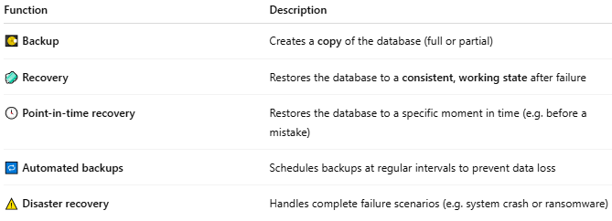
Function | Description
💽 Backup | Creates a copy of the database (full or partial)
🧼 Recovery | Restores the database to a consistent, working state after failure
🕓 Point-in-time recovery | Restores the database to a specific moment in time (e.g. before a mistake)
🔁 Automated backups | Schedules backups at regular intervals to prevent data loss
⚠️ Disaster recovery | Handles complete failure scenarios (e.g. system crash or ransomware)

📦 Types of Backup
# Source: AI Source: Provided by: [Data Path: Persons Table -> ID Column: 1, Name_En Column: Motasem Essam] -> From: [ChatGPT] on [6/10/2026]
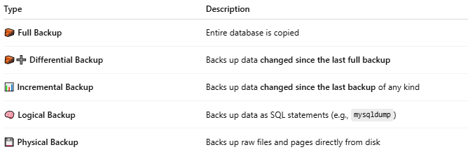
Type | Description
🧱 Full Backup | Entire database is copied
🧱➕ Differential Backup | Backs up data changed since the last full backup
📊 Incremental Backup | Backs up data changed since the last backup of any kind
🧠 Logical Backup | Backs up data as SQL statements (e.g., mysqldump)
💾 Physical Backup | Backs up raw files and pages directly from disk

🔁 Recovery Techniques
# Source: AI Source: Provided by: [Data Path: Persons Table -> ID Column: 1, Name_En Column: Motasem Essam] -> From: [ChatGPT] on [6/10/2026]
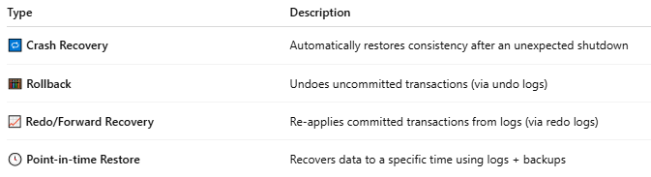
Type | Description
🔁 Crash Recovery | Automatically restores consistency after an unexpected shutdown
🧮 Rollback | Undoes uncommitted transactions (via undo logs)
📈 Redo/Forward Recovery | Re-applies committed transactions from logs (via redo logs)
🕓 Point-in-time Restore | Recovers data to a specific time using logs + backups

📚 Backup Tools in Popular DBMSs
# Source: AI Source: Provided by: [Data Path: Persons Table -> ID Column: 1, Name_En Column: Motasem Essam] -> From: [ChatGPT] on [6/10/2026]
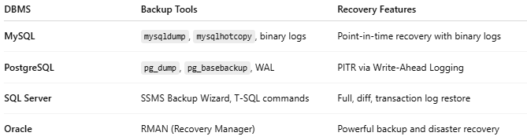
DBMS | Backup Tools | Recovery Features
MySQL | mysqldump, mysqlhotcopy, binary logs | Point-in-time recovery with binary logs
PostgreSQL | pg_dump, pg_basebackup, WAL | PITR via Write-Ahead Logging
SQL Server | SSMS Backup Wizard, T-SQL commands | Full, diff, transaction log restore
Oracle | RMAN (Recovery Manager) | Powerful backup and disaster recovery

🔐 Best Practices for Backup & Recovery
# Source: AI Source: Provided by: [Data Path: Persons Table -> ID Column: 1, Name_En Column: Motasem Essam] -> From: [ChatGPT] on [6/10/2026]
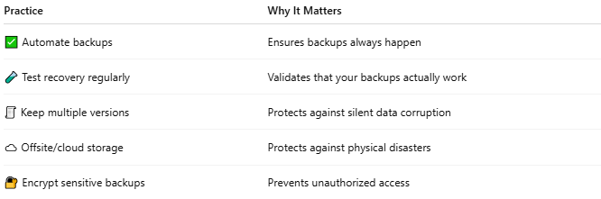
Practice | Why It Matters
✅ Automate backups | Ensures backups always happen
🧪 Test recovery regularly | Validates that your backups actually work
🧾 Keep multiple versions | Protects against silent data corruption
☁️ Offsite/cloud storage | Protects against physical disasters
🔐 Encrypt sensitive backups | Prevents unauthorized access

📌 Summary
# Source: AI Source: Provided by: [Data Path: Persons Table -> ID Column: 1, Name_En Column: Motasem Essam] -> From: [ChatGPT] on [6/10/2026]
The Backup & Recovery System protects your database from data loss and enables restoration after failures. It’s a vital part of data integrity, business continuity, and disaster preparedness.

